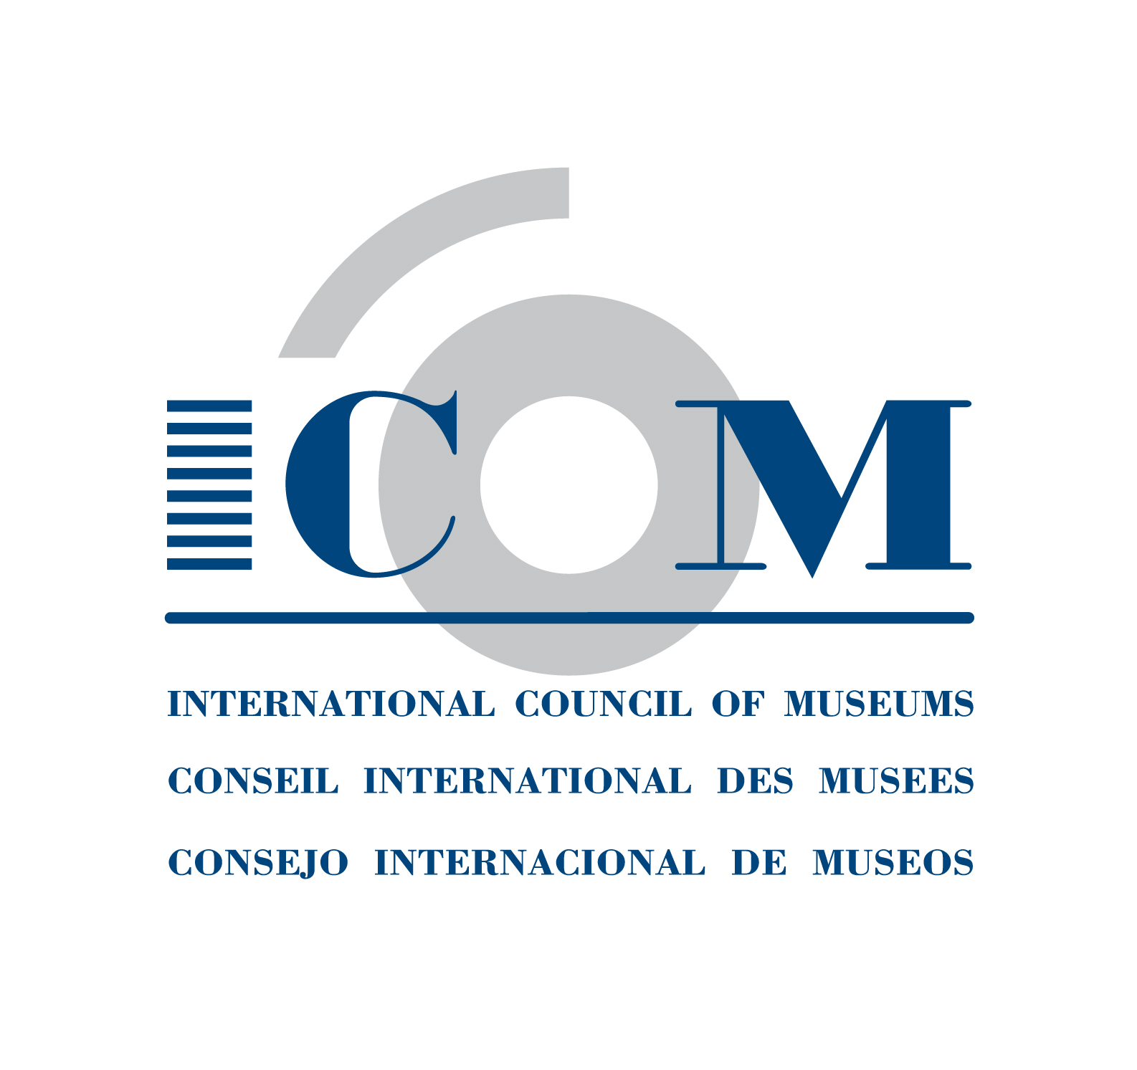  Tel + 33 (0) 1 47 34 05 00  Fax + 33 (0) 1 43 06 78 62  E-mail: membership@icom.museum  http://icom.museum | INSTITUTIONAL MEMBERSHIP  APPLICATION FORM  Please complete legibly and return to your National Committee  http://icom.museum/the-committees/national-committees

Name of institution in English (required):

Name of institution in your language :

Date of establishment (dd/mm/yy): Website:
Name of your Museum Director:

Institution contact details

Mailing address :

Postal code : E-mail:

City: Telephone:

Country : Fax:

Institution Designated Representatives and ICOM International Committee Memberships
Institutions can designate up to three of its employees, called designated representatives, to represent them on International Committees. This means that an institution may choose a Committee, and designate three representatives to this Committee.
Or, the institution may choose three different International Committees, and designate the same or different representatives to these Committees.
For more information on the ICOM International Committees, please see
http://icom.museum/the-committees/international-committees

Representative 1:
First Name and Last Name : Mr/Mrs/Ms/Prof/Dr______________________________________________________________
Position: E-mail: Telephone:
International Committee:
Representative 2:
First Name and Last Name : Mr/Mrs/Ms/Prof/Dr______________________________________________________________
Position: E-mail: Telephone:
International Committee:
Representative 3:
First Name and Last Name : Mr/Mrs/Ms/Prof/Dr______________________________________________________________
Position: E-mail: Telephone:
International Committee:

Language for correspondence: (tick one) □English □French □Spanish

Category of membership (based on the annual operating budget of the institution, less capital expenditures):
- Regular I (voting) < €30.000
- Regular II (voting) from €30.000 to €100.000
- Regular III (voting) from €100.000 to €1.000.000
- Regular IV (voting) from €1.000.000 to €5.000.000
- Regular V (voting) from €5.000.000 to €10.000.000
- Regular VI (voting) > €10.000.000
- Sustaining (voting)
- Contributing (voting)
- Supporting (non-voting)
Membership is annual and runs from January 1 to December 31 of the year.

Please tick the classification which apply to your institution:

A. CATEGORY OF INSTITUTION:
❑ Archives with Special Collections | ❑ Museum Service Companies and Consultants
❑ Botanical Garden | ❑ Natural Park
❑ Conservation Institute | ❑ Other Cultural Institutions/Centers
❑ Corporate Collections | ❑ Places of Worship
❑ Exhibition Gallery | ❑ Professional Association/Federation
❑ Government Agency | ❑ Research/Training Institute in Museum Studies
❑ Library with Special Collections | ❑ Zoo /Animal Reserve
❑ Monuments and Sites | OTHERS (please specify):
❑ Museum

B. GOVERNING BODY:
❑ Association | ❑ National
❑ City or Municipal | ❑ Private
❑ Foundation, Society, Trust | ❑ Region or Local
❑ International Organisation | ❑ University
 | OTHERS (please specify):

C. TYPE OF COLLECTION:
❑ Agriculture/Rural Heritage   Archaeology   Architecture   Audiovisual and Digital Art   Children's Museum   Decorative and Applied Arts and Design   Egyptology   Ethnology/Ethnography   Glass and Ceramics   Historic Houses and Gardens   History   Human Rights | ❑ Military History   Modern/Contemporary Art
 | ❑ Money or Bank Museum
 | ❑ Music
 | ❑ Natural Sciences
 | ❑ Open Air
 | ❑ Paintings and Graphic Arts
 | ❑ Performing Arts
 | ❑ Photography and Film
 | ❑ Prehistory
 | ❑ Science and Technology
 | ❑ Sculpture
❑ Industrial Heritage | ❑ Sports
❑ Literature | ❑ Textiles, Costume and Accessories
❑ Maritime | ❑ Transport and Communications
❑ Medicine, Health and Hygiene | OTHERS (please specify):

Note: The above information will be automatically processed to ensure your receipt of services from ICOM. In conformity with the French Law on Informatics & Civil Liberties (Jan. 6, 1978, rev.) you have the right of access and to modify the information that concerns you.

I, , declare that my institution is eligible for membership of the International Council of Museums (ICOM) and wishes to become a member of ICOM.
My institution does not engage in dealing (i.e. buying and selling for profit) in the field of cultural property and accepts the ICOM Code of Ethics for Museums.

Date: Signature:

October 2014

